# Python Youtube Downloader v2.0

Last Edited: 26th Dec, 2011

Author: Rahul Sinha

# Application Walk-through

First time users will be prompted with a configuration editor as shown below:

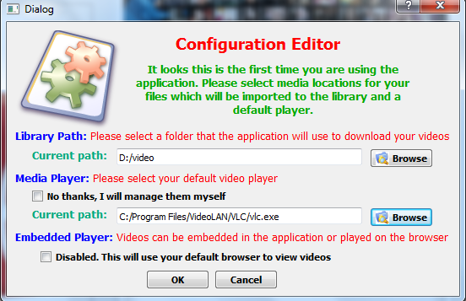

**Library Path:** This is the folder where all the downloaded files will be stored. A new folder can be created from the same dialog and used as library folder.

**Media Player:** This is the default media player used to play downloaded videos. Use this to specify the executable file location.

**Embedded Player:** The application can play media as embedded videos from its interface. However, it does possess some problems on certain platforms not using Mozilla as a browser. The application relies on the flash plugin that is used with Mozilla.

# Video Search

To search for videos, type the keyword that you are looking for in the search box and don’t select “Standard Video Feeds” and press “Search Button” as shown below:

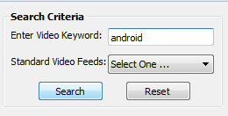

# Search Result View

The search results are populated in the “Videos” grid view as shown below:

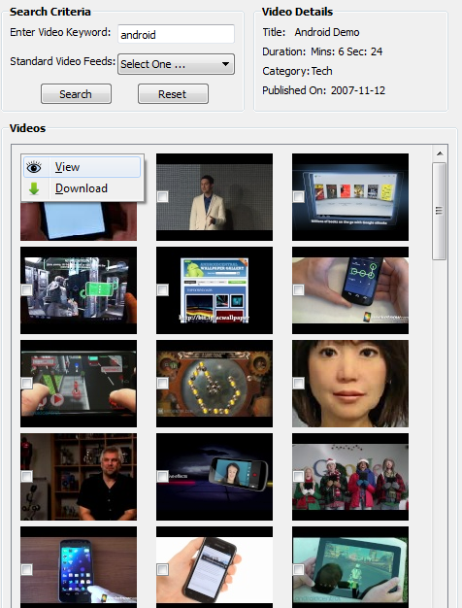As shown in the screenshot on the left, the videos are shown in a grid view. The videos can be viewed, either by right clicking on the image and selecting View OR double clicking on the video (which does not always work!).

The selected details for the video are shown on the top right pane with details like: Title, Duration, Category, Published date. The videos can be played from the Embedded Video pane as shown below:

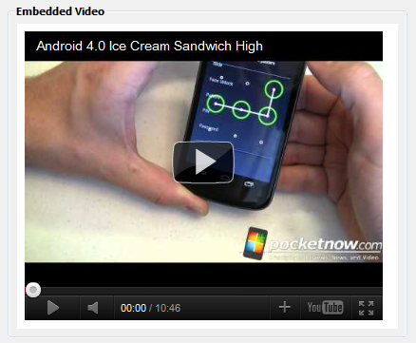

# Standard Video Feeds

Standard video feeds (1) Most Viewed (2) Top Rated (3) Recently featured (4) Most Discussed (5) Top Favorites (6) Most Responded (7) Most Recent.

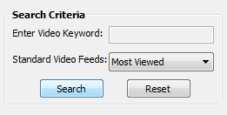A shown in the screenshot on the left, for standard feeds there is no keyword that can be used, just select the feed that you are interested in and click Search button.

# Downloading Videos

Videos for download can be selected either from the context menu – by right clicking on the video item and selecting “Download” OR even selecting the checkbox from the result pane.

The videos are then queued for download. The download begins when the user selects “Download” button. Videos queued for download can be removed from the queue list by selecting “Cancel Download” OR un-checking from the result list.

# Direct Video Links

Cannot find a video that you wish to download? You could paste your direct link for the video and the application will try downloading it. Note: not all videos from other sources can be downloaded; all youtube links will be OK to download unless they are copyrighted.

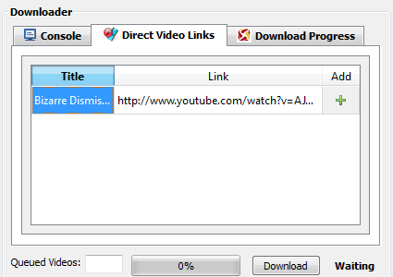

For using this, select “Direct Video Links” from the tabbed view as shown above and enter the following parameters:

(1) Title: This text is used to identify the downloaded video

(2) Link: This is the direct video link, for youtube this is the link like: <http://www.youtube.com/watch?v=AJp8jpDIycI>

(3) Press Add Button to add this to the list of queued videos for download.

The videos are queued for download and can be monitored from the download progress window as shown below:

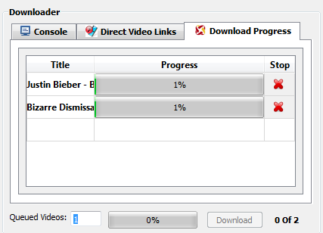 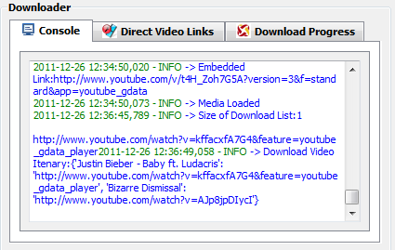

# Play Downloaded Videos

Downloaded videos are added to the folder as selected before as the “Media Library” folder. Every downloaded video has a subfolder named after the “keyword” that you searched for OR the name of the standard feed. The video name is the name of the video.

In case of direct video links, the folder name is “Direct Downloads” and video name is the title used for identifying the direct video link (as shown above).

## Video Library View

Video Library has the following three main components (1) root node – identified by “Video Library” in the view (2) Folder node – downloaded videos have their own separate folders (more later), (3) Video node – this is the actual video item that can be played.

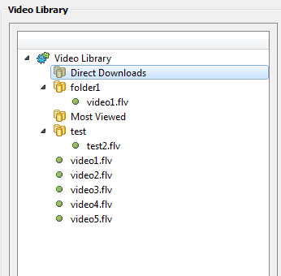

### Menu Actions on Video Library View:

The root node (Video Library) has following options:

1. Refresh – Highlight the root node and press F5
2. Expand/Collapse child items – Right click on the root node and select the appropriate actions

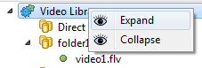

Folders in the library view has following options:

1. Rename – Right click on the item that brings the context menu
2. Delete – Same as above, please note for this to work the folder should be empty. If this hasn’t worked, browse to the folder using Windows and check if it is infact empty.

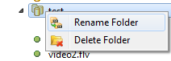

Video Files have the following options:

1. Play Video - this will play the video using the selected media player of your choice
2. Rename – renames the video item
3. Delete – deletes the video item

